Batch: A2
Roll No.: 16010122034
Experiment No.10

TITLE: Study of multiprocessor configuration concepts through Virtual lab

Aim
Understanding Virtual Lab concepts
_______________________________________________________________
Expected OUTCOME of Experiment

__________________________________________________________________
Books/ Journals/ Websites referred
http://www.vlab.co.in/
_____________________________________________________________________

Pre Lab/ Prior Concepts

The main aim of this experiment is to provide remote-access to Labs in various disciplines of Science and Engineering. These Virtual Labs would cater to students at the undergraduate level, post graduate level as well as to research scholars. Also, to enthuse students to conduct experiments by arousing their curiosity. This would help them in learning basic and advanced concepts through remote experimentation. It also provides a complete Learning Management System around the Virtual Labs where the students can avail the various tools for learning, including additional web-resources, video-lectures, animated demonstrations and self-evaluation. We can share costly equipment and resources, which are otherwise available to limited number of users due to constraints on time and geographical distances

Salient Features
. 1. Virtual Labs will provide to the students the result of an experiment by one of the following methods (or possibly a combination)
- Modeling the physical phenomenon by a set of equations and carrying out simulations to yield the result of the particular experiment. This can, at-the-best, provide an approximate version of the ‘real-world’ experiment.
- Providing measured data for virtual lab experiments corresponding to the data previously obtained by measurements on an actual system.
- Remotely triggering an experiment in an actual lab and providing the student the result of the experiment through the computer interface. This would entail carrying out the actual lab experiment remotely.
2. Virtual Labs will be made more effective and realistic by providing additional inputs to the students like accompanying audio and video streaming of an actual lab experiment and equipment.

Observations
Title of Study Experiment:

Brief description of experiment under study
A Karnaugh Map provides a pictorial method of grouping together expressions with common factors and therefore eliminating unwanted variables. The Karnaugh map can also be described as a special arrangement of a truth table.

K-Map Sun-of_products Design:
A minimal sum-of-product design can be created as follows:
- Create the K-map, entering a 1 or 0 in each square according to the desired logic function
- Beginning with large rectangles and going to small rectangles, add rectangles until all minterms are 'covered' (all '1's are included).
- Generate the algebraic terms corresponding to the rectangles

Examples:
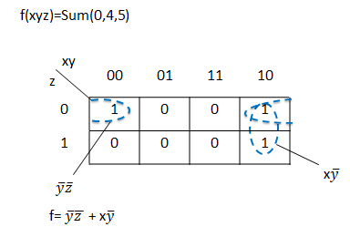

K-maps for Product-of-sum Design:
Product-of-sums design uses the same principles, but applied to the zeros of the function.

Examples:
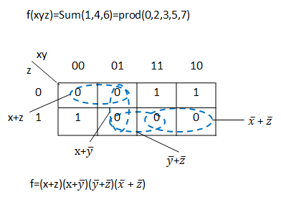
Designing with Don’t-Care Values:
In some situations, we don't care about the value of a logic function. For example, if we use wxyz to represent a number from 0 to 9, we need not worry about the function value produced for wxyz = 10...15. For these situations, the function can be assigned an output in order to make the resulting circuit as simple as possible Suppose we wish to implement the function f(wxyz)=Sum(3,5,6,7)and we have the don't-care condition of d=Sum(10,11,12,13,14,15).

The sum-of-products implementation:
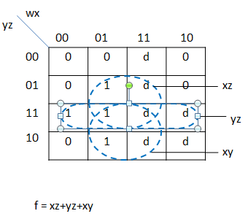

The product-of-sums implementation:
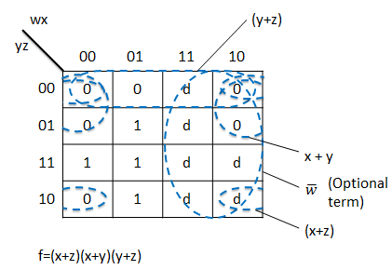

Karnaugh Maps-Rules of Simplification:
The Karnaugh map uses the following rules for the simplification of expressions by grouping together adjacent cells containing ones
- Groups may not include any cell containing a zero
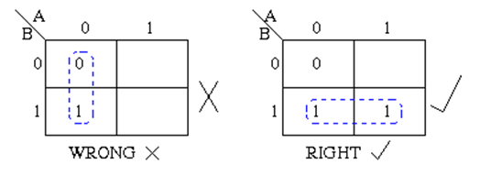
- Groups must contain 1, 2, 4, 8, or in general 2n cells. That is if n = 1, a group will contain two 1's since 21 = 2. If n = 2, a group will contain four 1's since 22 = 4.
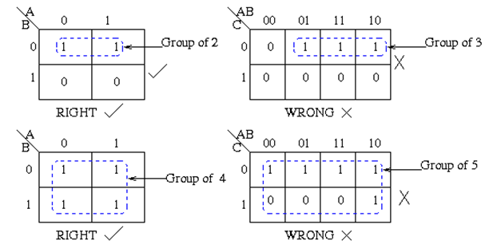
- Each group should be as large as possible.
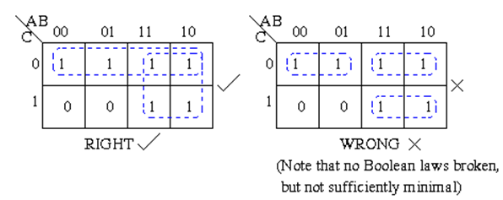
- Each cell containing a one must be in at least one group.
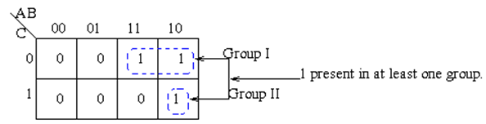
- Groups may overlap.
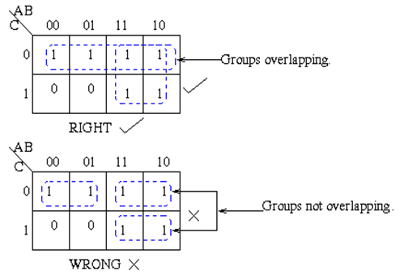
- Groups may wrap around the table. The leftmost cell in a row may be grouped with the rightmost cell and the top cell in a column may be grouped with the bottom cell.
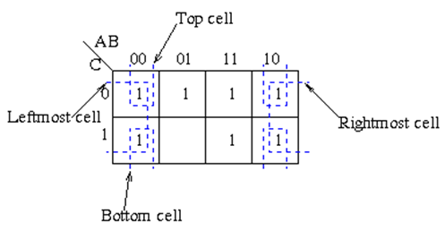
- There should be as few groups as possible, as long as this does not contradict any of the previous rules.
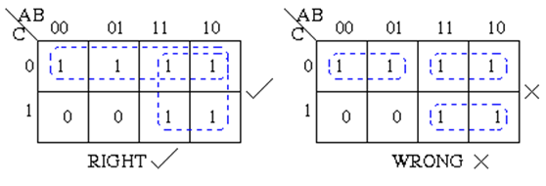
Karnaugh maps are used to simplify real-world logic requirements so that they can be implemented using a minimum number of physical logic gates. A sum of product expression can always be implemented using AND gate feeding into an OR gate, and a product of sum expression leads to OR gates feeding an AND gate.

Learnings recorded/ Screenshots
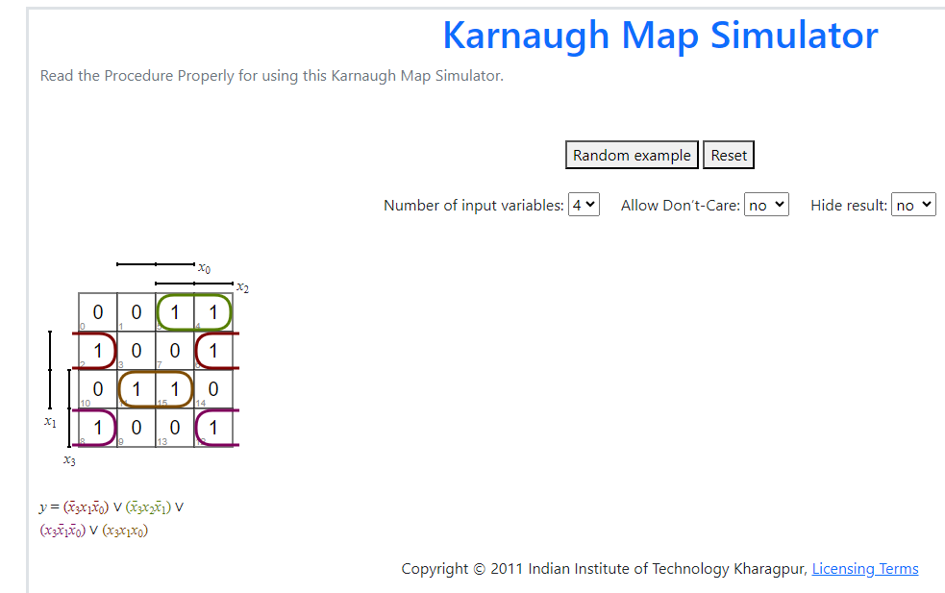
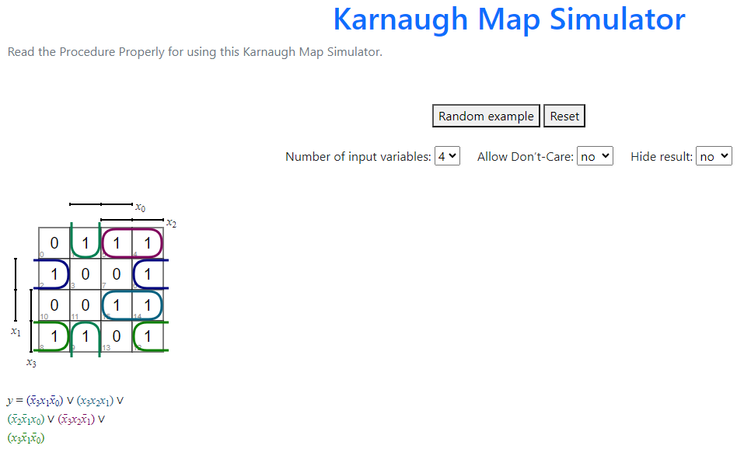
Knowledge gained / Inference Obtained

Post Lab Descriptive Questions
1. What are the applications of the virtual lab case study / tool reviewed by you?

Conclusion

